“Different ships”
Partnership Building Seminar on raising awareness and fostering knowledge on different migrants and refugee’ cultures and using cultural encounters as a positive tool of youth exchanges according to KA1 of Erasmus + programme
13-20 December 2019, Manchester, UK

Themes of the partnership building seminar:
Our organisation already runs projects based on tolerance, living together, sharing cultural diversity, local multiculturalism. Our experience is that, if in a project Refugees and local young people participate together, they can enjoy the cultural diversity, and learn a lot about each others culture. Refugees and migrants live everywhere in the European Union. On one hand they are seen as a big challenge by different societies because they go against the written and unwritten rules of mainstream societies; they follow their own rules which are not always understood by the majority; perhaps they do not necessarily want to be integrated into the majority, or if they do, they become outsiders from their own cultural communities and the majority don’t accept them either. Of course, it depends what type of migrants’ culture we meet. The culture of ‘migrants’ is much broader and more diverse than perceived by european cultures, which tend to generalise migrants, develop prejudices and stereotypes, as well as negative opinions. These stereotypes and opinions need to be challenged.

Our partnership building seminar aims to bring together youth workers, youth leaders, project managers directly working with young people and people with a migrant or a refugee background in order to explore together migrants’ culture and to share the political, cultural, educational, economic approaches of different countries towards migrants and refugees. The seminar will give participants the opportunity to share ideas, discuss various approaches on working with refugees and migrants; and develop youth projects that challenge stereotypes and prejudices, bring people together and celebrate intercultural youth work.

In this seminar we plan to build partnerships between organisations working with migrants and young people through supporting each others’ local work and inventing youth exchanges together for two reasons:
- Migrants and refugee young people from different cultures from different countries can meet each other and share their cultural background. Maybe this way they can better understand their roots and gain positive point of views for their future.
- European and migrants’ young people can get to know each other better and use migrant culture as a positive tool during the youth exchanges.

So the overall aim of this long term project is to provide a safe space and opportunity for youth workers, youth leaders from European and migrant’ communities to work together, to share their information and knowledge on migrant’ cultures, to break stereotypes and prejudices concerning migrants’ people and share experiences how to bring different groups of young people together. To get familiar with the diverse migrants’ cultures and use it as positive tool in youth work. To establish partnerships and devise youth exchanges in order to involve young people from European and migrants’ communities, to work together and gain knowledge about migrants’ cultures.

Learning objectives of the partnership building seminar are:
- To share and explore together the different elements of migrants and refugees’ cultures in different countries;
- To find the impact on migrants’ culture in the mainstream culture in order to recognise the mutual intercultural learning between European and migrants and refugees’ communities;
- To share methods and techniques on working with European and migrants and refugees young people together in order to break the stereotypes and prejudices;
- To devise and develop youth exchanges together in order to involve young people from European and migrants and refugees’ communities to act together and gain knowledge about migrants’ cultures;
- To build solid partnership among represented organisations.

The methodology of the partnership building seminar:
Experienced trainers will prepare the methods based on the expectations and needs of the participants. They will provide participatory and creative methods, which will ensure the participation of experienced and less experienced participants. Some methods we will plan to use: individual, pair and mixed group work, drawings, montage/collage, group discussions, brainstorming, role play, methods’ market, preparing a booklet, visit to good practice project, idea and project development, etc.

PARTNER ORGANIZATIONS RESPONSIBILITIES:
Before the activities:
- promote the opportunity of the project and selection of the most eligible participants according to the profile, respecting non-discrimination policy, but ensuring the gender equality;
- inform the participants about their responsibilities and rights during the project according to ERASMUS+ guidelines and the planned activities;
- instruct the participants about the transportation options they have;
- send the application form of the participants to the organisers to help defining the logistics and agenda of the activity;
- support and guide the participants during issuing European Health Insurance Card;
- get an emergency contact of each participant;
- assist the participants in preparing for activities preparing for presenting the sending organisation and the country of origin;
- Inform the participants about the YouthPass certificate;
- communicate and inform participants for any changes during the preparatory activities;
- Ensure the visibility of the project and ERASMUS+ Programme, respecting the visual identity rules of it, through publications on it's respecting online (FB, web page, Twitter, etc) and offline platforms (newspapers, magazines, meetings, etc.).
During the activities:
- maintain regular communication with the coordinating organization during the implementation of the activities;
- In case of emergency, contact the person indicated as emergency contact person.
After the activities:
- Implement all the dissemination activities planned:
- Publishing articles and pictures on the organization’s online and offline communication channels;
- Respect the deadlines for implementing the dissemination activities and reporting.
- Supervise that the participants send all the return transportation documents.
- Provide the information needed to the coordinacoordininoting organization for the final report that has to be presented to the NA.

Who can participate in the partnership building seminar:
Youth Workers, Youth Leaders, Volunteers, Managers, Young people aged 18 who:
- represent the needs of the partner organisations;
- represent the needs, expectations and interest the European and migrants’ young people they work with in daily basis;
- represent their personal learning goals;
- have experience of working with European and migrants and refugees young people together;
- represent a migrant’ culture what they know closely or belongs to;
- are able to communicate in English;
- are ready to run and participate in youth exchanges with their target groups after the PBS;
- are ready to adapt methods and techniques learnt during the PBS in their daily youth work;
- are ready to become part of an international network for at least 2 years and be an active member.

Financial conditions:
The food and accommodation will be provided and paid by the organizers. Travels costs will be counted based on the distance calculator of European Commission and reimbursed either by bank transfer after the course or at the end of the course in cash (in Euros €). It may be that money from European Commission will be late; in that case, as mentioned, you will get your reimbursement after the course by bank transfer (be ready for that).

1. Croatia – 275 euro/participant
2. Romania – 360 euro/participant
3. Hungary – 275 euro/participant
4. Slovakia – 275 euro/participant
5. Bulgaria - 360 euro/participant
6. Turkey – 530 euro/participant
7. Lithuania – 275 euro/participant
8. Italy- 275 euro/participant
9. Greece- 360 euro/participant

Partner organizations: Beat Bazaar ProjectsDiem-Croatia- United Kingdom, Carpe Diem- Croatia, Teruletfejlesztok a Videkert Egyesulet- Hungary, Ady Endre- Romania, ADEL- Slovakia, The Starry Start of Talents Foundation - Bulgaria, GEDED- Turkey, VšĮ Inovacijų biuras- Lithuania, Vele Corsare- Italy,HYP-Greece

Participants: 4/country

About Manchester:
Manchester is a city and metropolitan borough in Greater Manchester, England, with a population of 530,300 as of 2015. It lies within the United Kingdom's second-most populous urban area, with a population of 2.55 million. Manchester is fringed by the Cheshire Plain to the south, the Pennines to the north and east and an arc of towns with which it forms a continuous conurbation. The local authority is Manchester City Council.

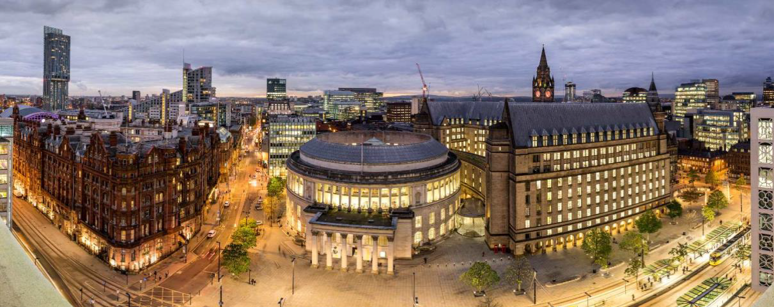
Accommodation:

The participants of the training course will be hosted in the Travelodge Altrincham Central: https://www.travelodge.co.uk/hotels/544/Altrincham-Central-hotel . 3 participants are going to be accommodated in one room, with a separate bathroom.

Activities:
The activities of the training course will take place in Sharon Youth Centre (Cornbrook St, Manchester, M16 7QB). We will go there together with the group every day.
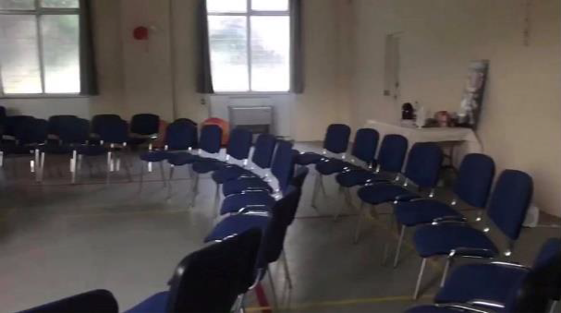
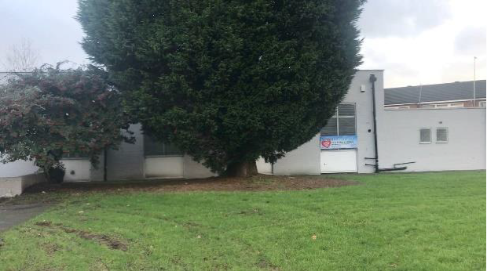

WHAT TO BRING WITH YOU?
  - your passport or ID card
  - All your travel tickets!!! (it's very important to keep all your ticket, receipts and boarding passes, because we can give you back the travel costs only if you have the tickets)
  - National snacks, drinks, easy food, specialties, local music for thecultural evening – please think about snacks and specialties, which does not require to be kept in the fridge, as we may not have access to fridge in the hotel
  - presentation of your organization (please bring some introduction materials about your organization or information about it)
  - Medicines - if you need them (anti-allergy pills, pain killers, aspirin etc.)
  - Laptop, camera – it is not obligatory, but it can be useful

Preliminary programme of the TC1:
Hours | Day 1  Arrival day | Day2 | Day 3 | Day 4 | Day 5 | Day 6 | Day 7 | Departure day
 | WELCOME | Get 2 know | Day of migrants and refugees’ culture | Day of migrants and refugees’ youth | Day of good practice project | Day of future projects | Day of partnership | FAREWELL
8.00 – 9.00 | Arrival  of participants | Breakfast | breakfast | Breakfast | Breakfast | Breakfast | Breakfast | Breakfast
9.30– 13.00  (Including coffee break) | Arrival  of participants | The aim and objectives of PBS  Getting to know each other  Review of the programme methods and particular features of the PBS | What is migrants and refugees’ culture? II.  Presentation of the represented organisations | Methods’ market on methods and techniques on working with European and migrants/refugees young people together in order to break stereotypes and prejudices | Visit to good practice project concerning to cooperation between local and migrants/refugees communities | General overview of the new programme Erasmus +  Refreshing the knowledge on youth exchanges | Create Recommendations on projects for using cultural encounters as positive tool  Personal and group action planning  Partnership building | Departure  of participants
13.00 – 15.00 | Lunch | Lunch | Lunch | Lunch | Lunch | Lunch | Lunch | Departure  of participants
15.00 - 16.30 | Registration and accommodation | Organisations – Target groups  Projects with local and migrants/refugees young people | Intercultural learning I.  How are migrants/refugees people seen by mainstream society? | Preparing an Introduction booklet on shared methods and techniques as using cultural encounters as positive tool in youth work  Forecast groups | Free afternoon (or optional programmes organised by participants) | Working on project proposals for using cultural encounters as positive tool | Fill in Youthpass certificate | Departure  of participants
16.30 – 17.00 | Coffee break | Coffee break | Coffee break |  |  | Coffee break | Coffee break | Departure  of participants
17.00 - 18.30 | Warming up activities | What is migrants/refugees culture? I.  Presentations and discussions by/with migrants/refugees experts | Intercultural learning II.  How are mainstream societies seen by migrants/refugees people? |  |  | Working on project proposals for using cultural encounters as positive tool  Guidance and consultation  Forecast groups | Evaluation of the PBS | Departure  of participants
18.30-19.00 | Warming up activities | Forecast groups | Forecast groups |  |  |  | Preparing the Farewell evening | Departure  of participants
19.30-20.30 | Dinner | Dinner | Dinner | Dinner | Dinner out | Dinner | Dinner | Departure  of participants
21.00- | Welcome evening | Migrants’ Evening | Presenting migrants’ cultures e.g. dance, song, etc. | Movie Night | Karaoke night | Working evening | Farewell Evening | Departure  of participants

PERSONAL DATA
First name:
Family name:
Nationality:
Date of birth:
Gender:
Complete address:
Postal code:
Town:
Country
Phone number:
Fax:
E-mail:
Size of T-shirt:

Do you have any special needs or requirements that the host organisation should know about? (E.g. mobility, medical needs, allergies, dietary restrictions, smoker/non-smoker)

Language(s) abilities: Please mention all languages in which you are able to work and indicate your level for each (B-basic, G-good, VG-very good, F-fluent, MT-mother tongue). The main working language of the TC will be English.
 | Listening |  | Speaking | Reading | Writing
English
Other languages
[please specify]
KNOWLEDGE AND EXPERIENCES
What are your roles (volunteer, youth worker, board member, director ...) and your tasks at your organization? Please tell us how long you have been involved in youth work?
What type of training (if any) have you followed regarding voluntary work or volunteer management, international youth work, non-formal education, Youth in Action and Erasmus+ programme?
Please shortly describe your experience in the YiA and Erasmus+ programme and the actions above.
(E.g. type of projects, your role - organiser / participant / trainer or facilitator etc.)
MOTIVATION AND EXPECTATIONS
What would you like to learn, understand and experience during this mobility?
What contributions can you bring for the mobility?
How do you plan to use the experience from this mobility in your work within your organisation afterwards?

Please indicate us the name and full contact details of a person to be contacted in case of emergency during the seminar:
First name:
Family name:
Complete address:
Postal code:
Town:
Country
Phone number:
Fax:
E-mail:
Web:

Please take note of the following conditions that will apply, if you are selected to take part in the partnership building seminar.
- I commit myself to participate in the whole process, including:
- to prepare myself carefully for the partnership building seminar and to do all remote preparation work the team will ask for,
- to take part in the full duration of the partnership building seminar
- to participate in the whole evaluation process
- I understand that the information I provided on my special needs does not remove my own personal responsibility for ensuring my own health.

