

- PROJECT DETAILS
What is the type of the project that you’re applying for? (Highlight answer please)
- Youth Exchange (razmjena mladih)
- Training Course
- European Solidarity Corps (volunteering projects)
What is the name of the project and the activity dates of the project that you are applying for?
…………………………………………………………...
- LANGUAGE ABILITIES

LANGUAGE | WELL | ENOUGH | POOR
English
*Write as many languages as want
- PERSONAL DETAILS

PERSONAL INFORMATION
NAME
SURNAME (FAMILY NAME)
GENDER
BIRTH DATE
PLACE OF BIRTH
NATIONALITY
PLACE OF RESIDENCE and FULL ADDRESS
MOBILE PHONE (with international code)
E-MAIL
FACEBOOK
EMERGENCY CONTACT
NAME
PHONE NUMBER

OTHER INFORMATION (Highlight answers please)
Do you have a valid Passport?  If yes, please provide the number of the document: | YES | NO
Is your Passport available for 6 more months from now on? | YES | NO
Have you participated in any international activity? | YES | NO
Have you participated in an Erasmus+ project before? If yes, where? | YES | NO
Do you smoke? | YES | NO
Are you vegetarian? | YES | NO
Are you vegan? | YES | NO
Do you have an allergy to milk, or other products made of milk ?  If yes, please specify. | YES | NO
Do you have any other allergy?  If yes, please specify. | YES | NO
Do you need special medication?  If yes, please specify. | YES | NO
Do you have medical problems/  disabilities? If yes, please specify. | YES | NO
Do you have any special skills that you can share with us (for example: acting, painting, playing an instrument, making people laugh..)? If yes, please specify. | YES | NO
Please, write down your top 4 fileds of interest, regarding to Erasmus+ projects:

If you would like to add anything, please write here:

GDPR: Slanjem ovog kontakt obrasca suglasan/a da se moji osobni podaci prikupe i obrađuju isključivo u svrhu za koju su i prikupljeni. Također, potvrđujem i da sam obaviješten/a da Ocean Znanja u RH posluje sukladno zahtjevima Opće uredbe o zaštiti podataka 2016/679 (GDPR) koja propisuje da dani osobni podaci neće biti proslijeđeni trećim osobama bez moje daljnje privole i da će biti čuvani na siguran način sukladno zahtjevima Uredbe sve dok za tim postoji potreba ili ne postavim zahtjev za povlačenjem suglasnosti, brisanjem, ograničenjem ili ispravkom podataka.

- INVOLVEMENT IN YOUTH WORK

PLEASE DESCRIBE YOUR PREVIOUS EXPERIENCES IN THE FIELD OF (INTERNATIONAL) YOUTH WORK(Working with youth):

PLEASE DESCRIBE YOUR OWN PERSONAL MOTIVATION FOR ATTENDING THIS YOUTH EXCHANGE / TRAINING COURSE / ESS (EXPLAIN WHY YOU ARE THE PERFECT CHOICE):

- MOTIVATION, EXPECTATIONS AND NEEDS


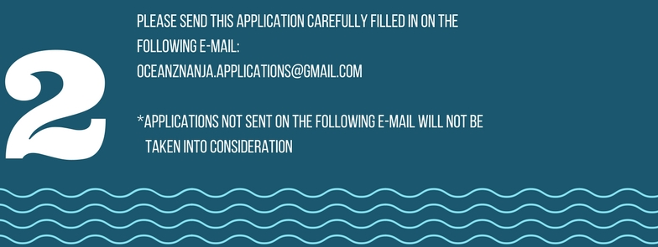

Contact person:
Zrinka Suk: +38598372964; zrinka.suk@gmail.com

